# MINOR PROJECT 1

### Vikash Kumar |

### wiryvikash15@gmail.com

### INFORMATION GATHERING & EXPLOITATION

#### Take some random websites using Google Hacking Database and enter into their admin panel using SQL Injections.

#### Execution:

#### Step 1: Go to Google Hacking Database and search for the exploitation commands to exploit admin pages.

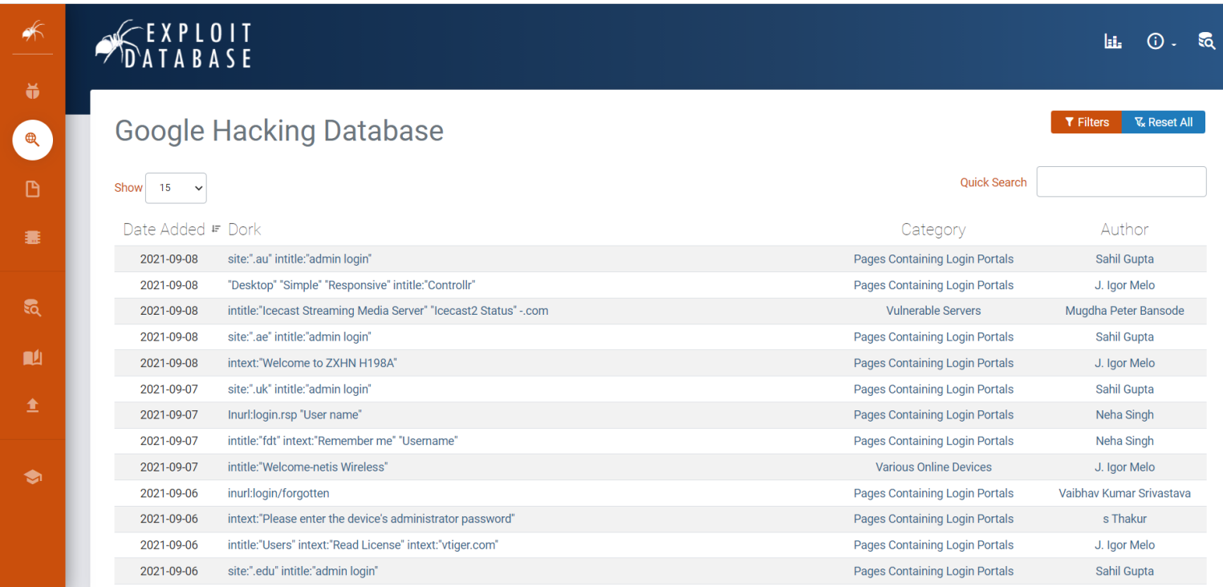

#### Step 2: Copy the command and search on google.

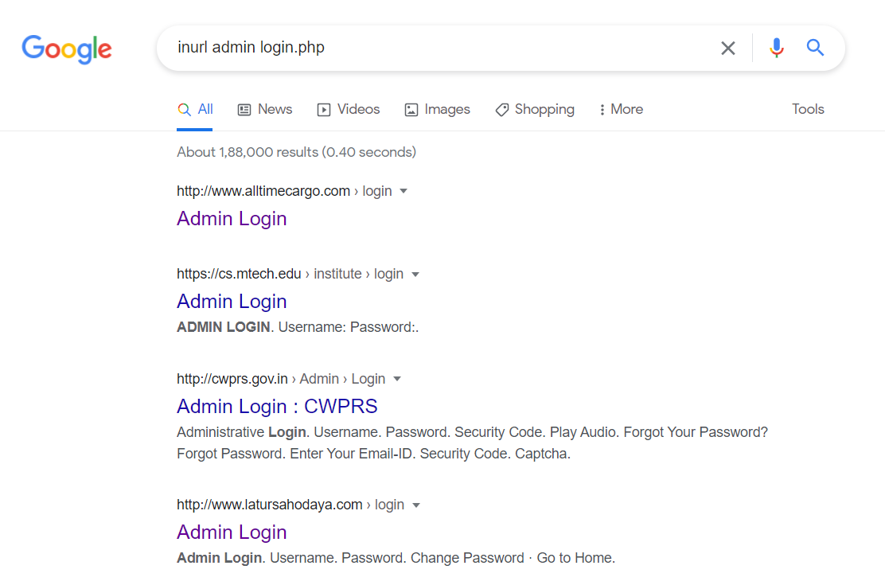

#### Step 3: Randomly open the different websites but DON’T open .edu or .gov sites.

#### Step 4: Insert the payload 1’ or ‘1’=’1 in Username and password, it will give access to the admin page.

Website 1:

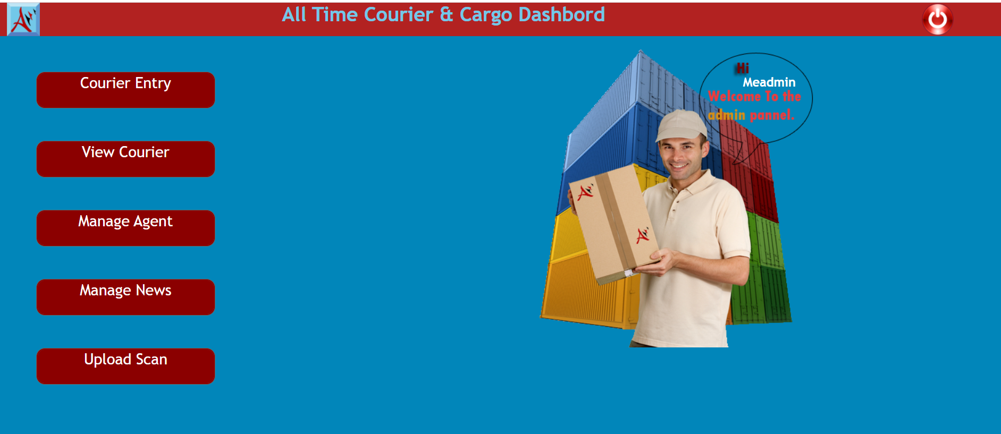

Website 2:

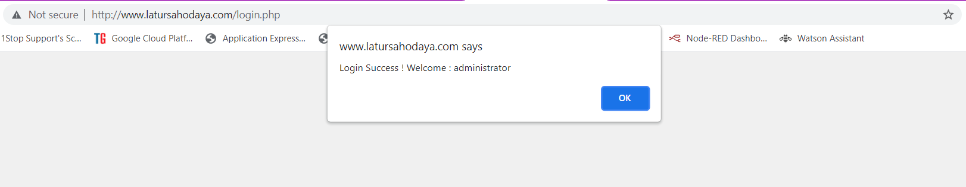

Website 3:

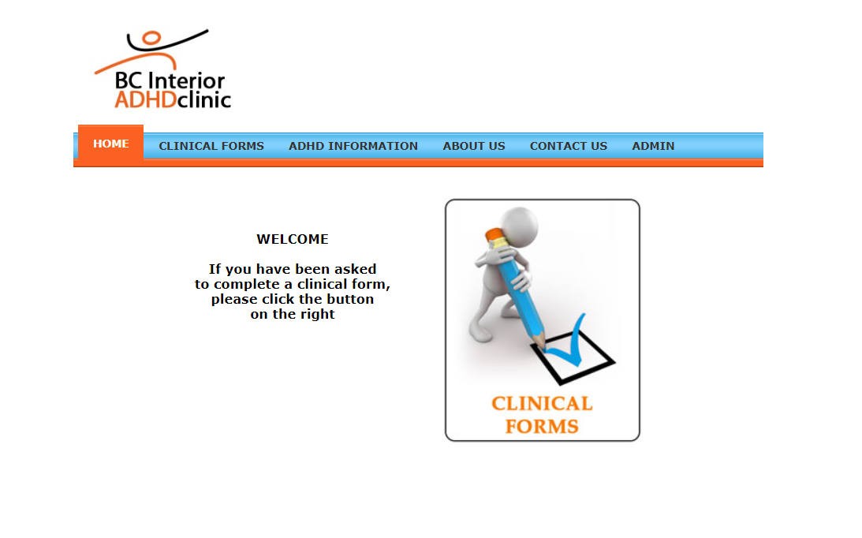

#### Step 5: Open the burp-suite.

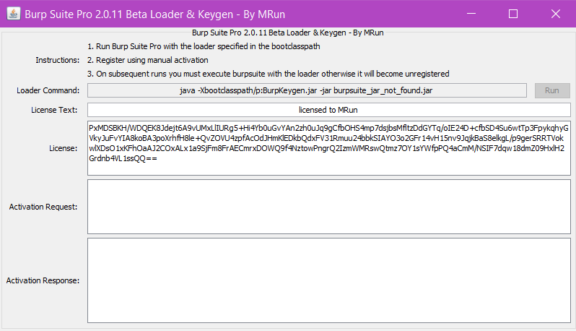

#### Step 6: Run the burp-suite.

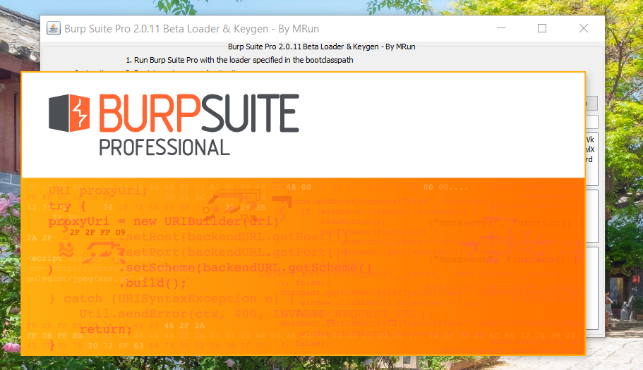

#### Step 7: Clear the temporary files.

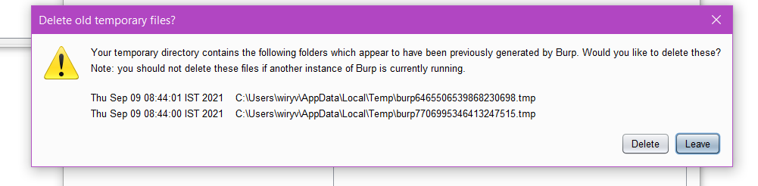

#### Step 8: Start the burp.

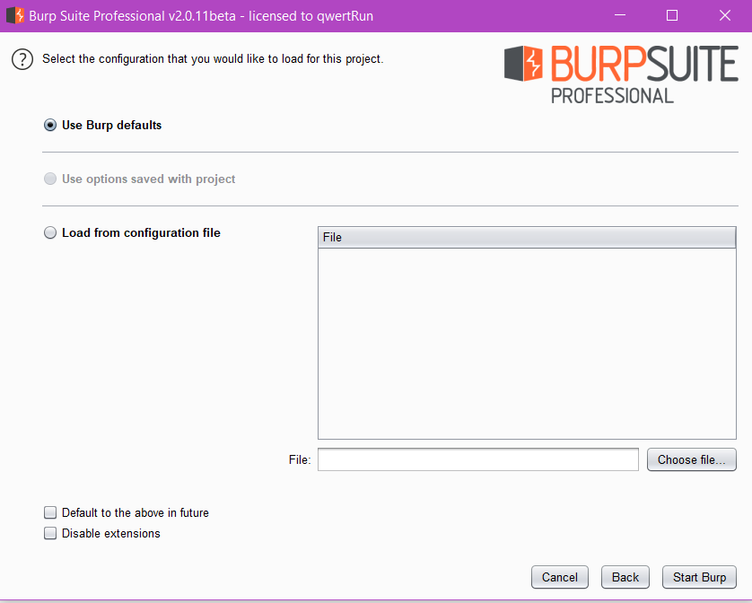

#### Step 9: The dashboard of Burp will be appeared.

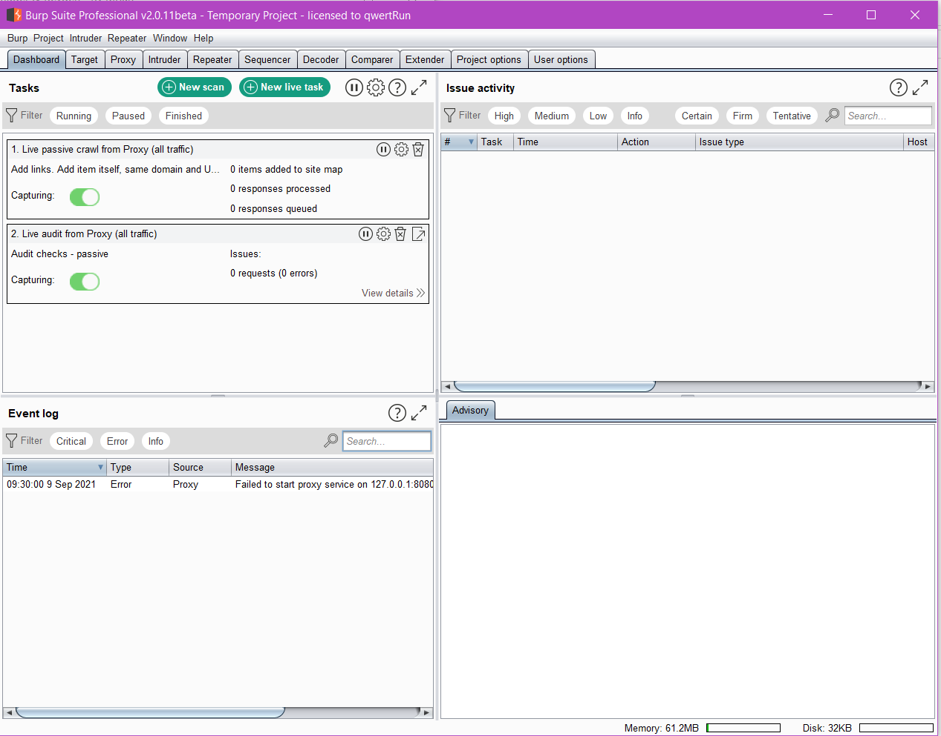

#### Step 10: Go to Proxy Server and turn on intercept to capture the packets and then turn off.

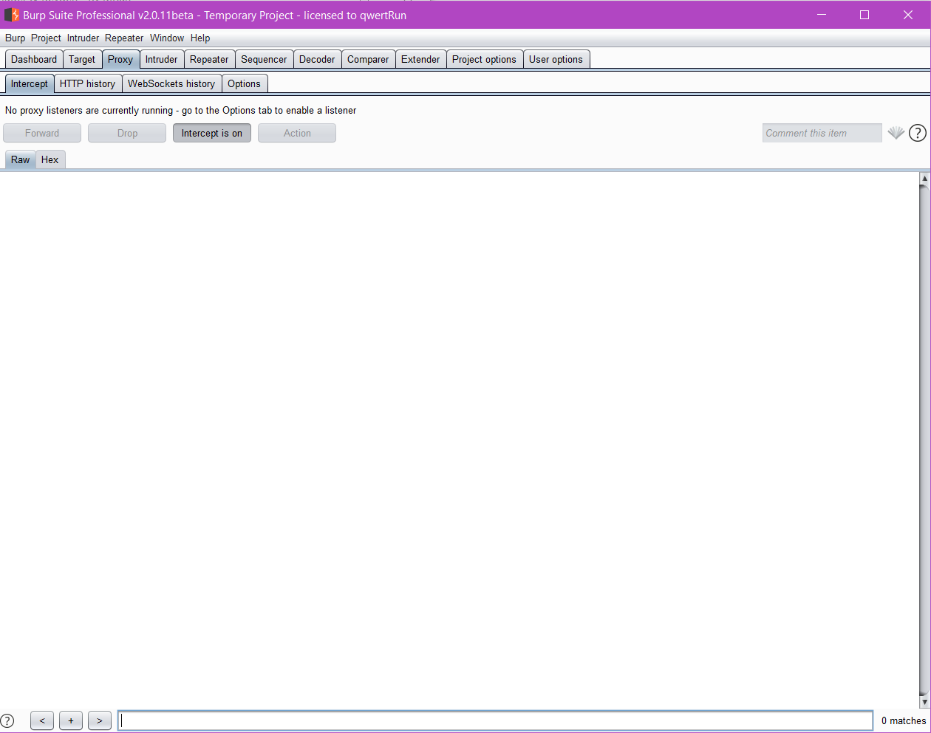

## Show some live cameras using Google Hacking Database.

### Execution:

### Step 1: Go to GHDB and copy the command and then search on google.

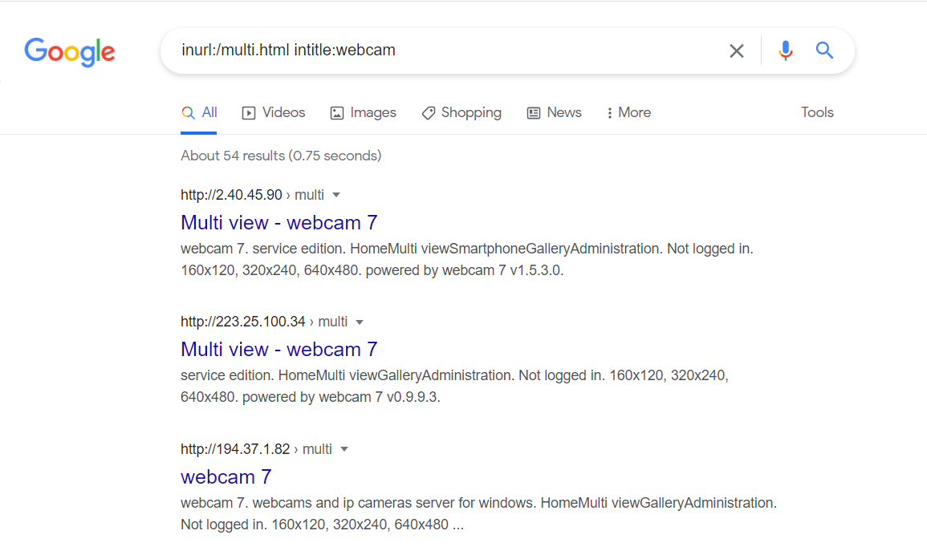

#### Step 2: Open the random websites and now you can access the live cameras in different locations.

Webcam 1:

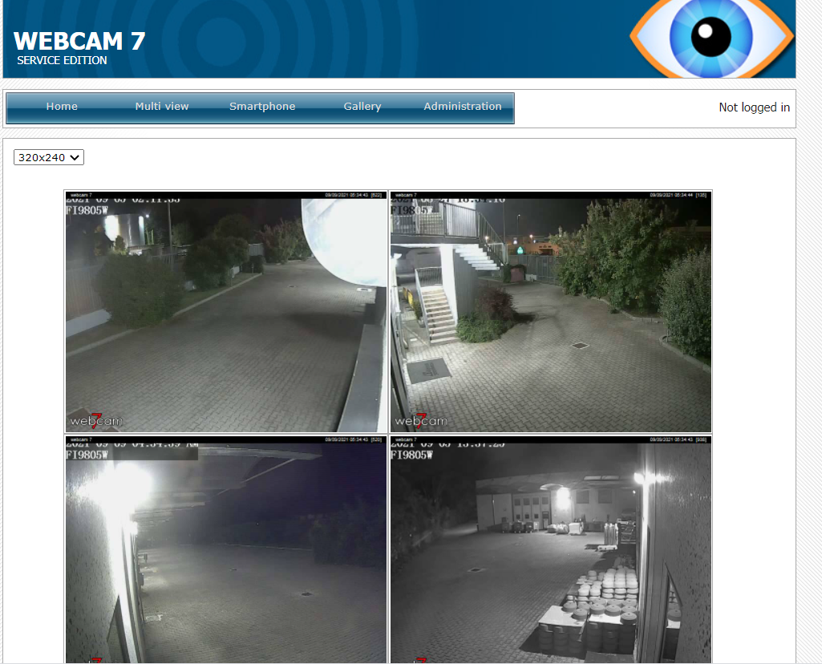

Webcam 2:

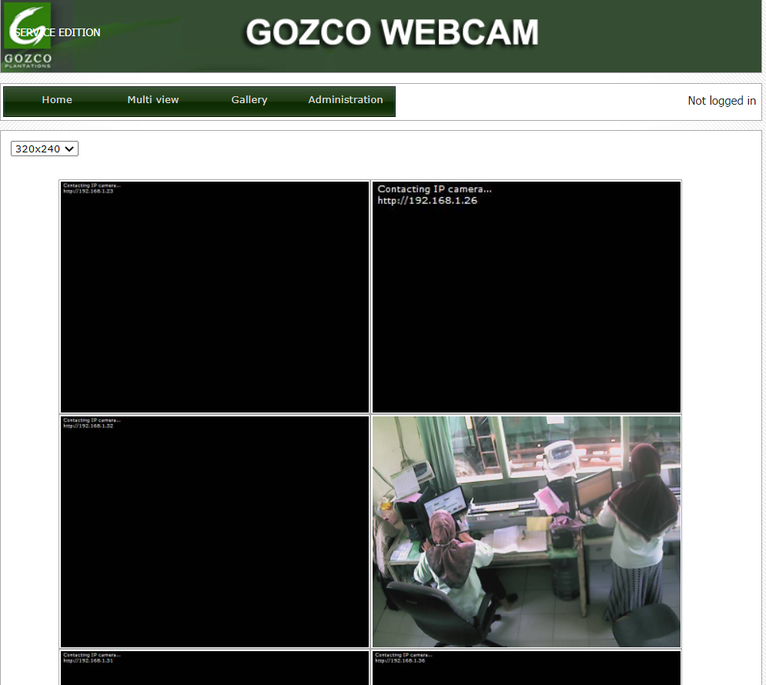

Webcam 3:

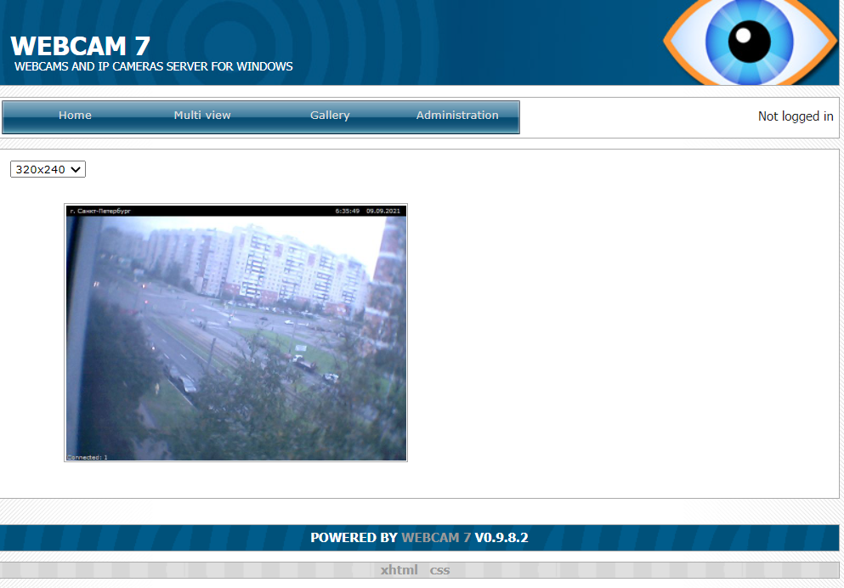

Webcam 4:

